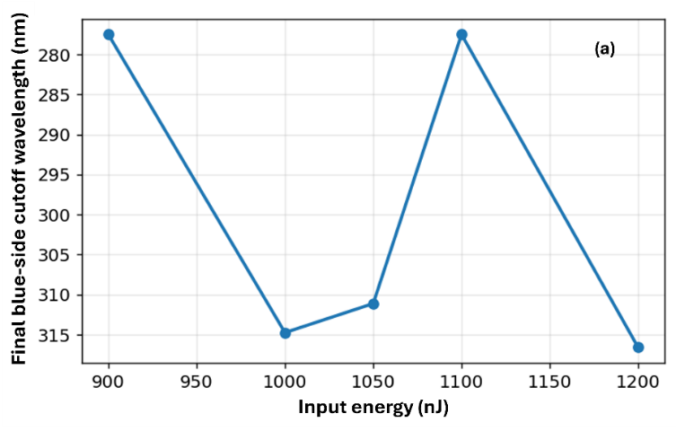
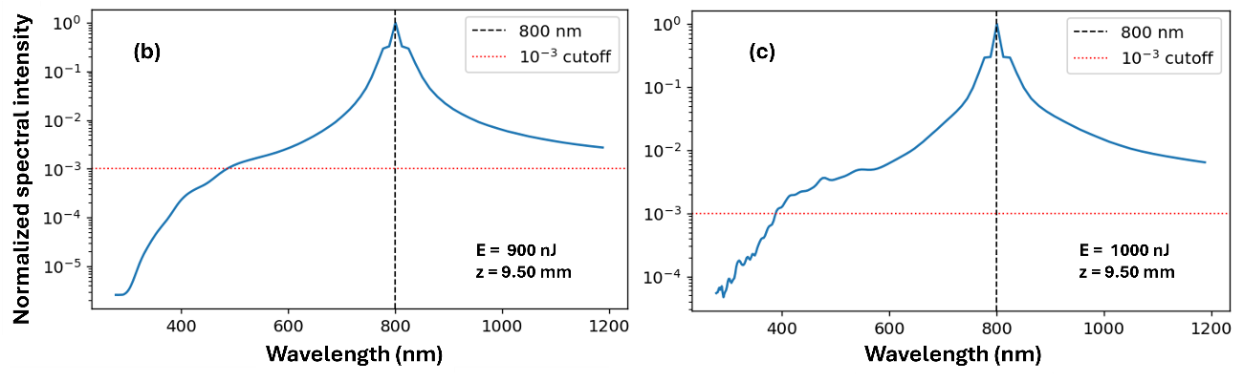
Figure 2. Spectral broadening in fused-silica vortex propagation. (a) Final-output blue-side cutoff wavelength versus input energy for the fused-silica m=1 vortex simulations. The cutoff is defined at the 10⁻³ level of the normalized spectrum on the blue side of 800 nm. (b,c) Representative spectra for selected input energies near the nonlinear-collapse regime. The dashed vertical line marks 800 nm, and the horizontal dotted line marks the 10⁻³ cutoff criterion. The broad blue-side extension demonstrates strong nonlinear spectral broadening, although cutoff values approaching the numerical bandwidth limit near 276 nm are interpreted qualitatively.

